POWER QUERY – CLEANING AND TRANSFORMING RAW DATA
- Rename the table as Customer Data
- Remove the estimated salary column
- Renaming columns
- Changing Data types
- Categorising the Product column > Add column tab > Column From Examples > New column named Products > Removing the product column
- Categorising the Age column by using the Conditional Column tab and create Age categories so we can analyse this data around those categories
- Categorising the Credit Score column by using the conditional column tab and create Credit Score categories so we can analyse this data around those categories
- Categorising the Balance column by using the conditional column tab and create Balance categories so we can analyse this data around those categories
- Sorting (re-ordering) the Age Groups, credit scores and Account Balance columns so It will be useful when creating charts and graphs. In order to do so, I duplicate the main table Customer Data, rename the newly created table as Age Groups, remove all the columns other than age Groups, remove duplicates in the column Age Groups. Now I need to create a conditional column called Age Groups ID and sort ascending the different age groups. The same procedure for Credit Score column and Account Balance column.
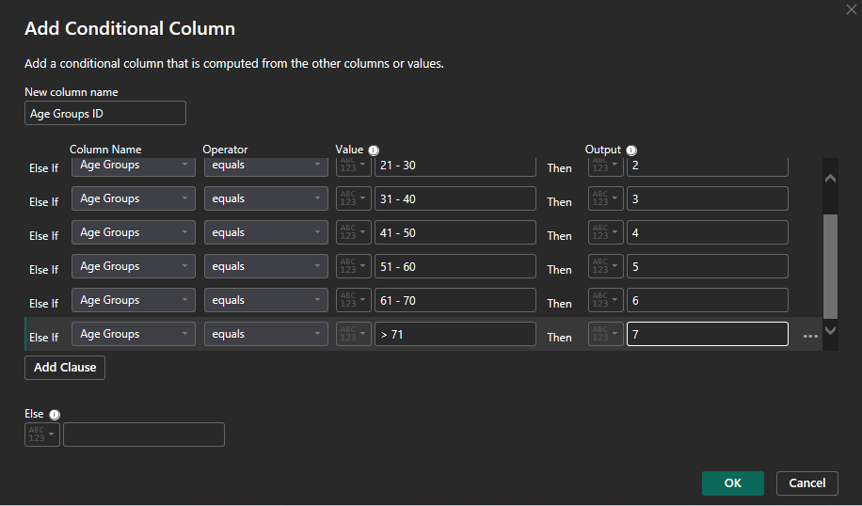

- 3 custom columns to calculate the Min Churn Rate, Max Churn Rate & Target Churn Rate
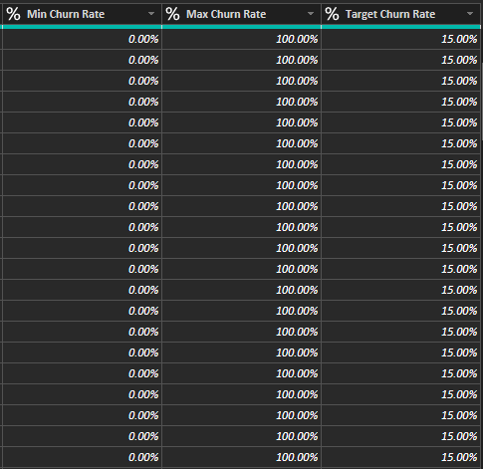

DAX MEASURES

AFTER CREATING THE MEASURE TABLE, I carried on with some calculations with DAX measures:

Total Number of Customers = COUNT('Customer Data'[Customer ID])

Number of Customers Lost = CALCULATE([Total Number of Customers], 'Customer Data'[Churn Status] = "Churned")

Churn Rate = [Number of Customers Lost] / [Total Number of Customers]

VISUALS

- 3 cards: total number of customers, total number of customers lost, churn rate
- 5 donut charts showing the total number of customers broken down by genders, activity status, credit card status, country and products
- 3 Line and clustered column charts showing total number of customers and churn rate broken down by age groups, total number of customers and churn rate broken down by credit scores & total number of customers and churn rate broken down by account balance
- Slicer indicating ‘churned’ or ‘not churned’
- Gauge Chart showing the Churn Rate and Target Churn Rate of 15%

